**Linkedin**

**(Your Brand)**

## 1. Choose the right profile picture for LinkedIn.

* We all are visual beings

Here are a few [examples & Tips for Prof LinkedIn Photo:](https://www.linkedin.com/business/talent/blog/product-tips/tips-for-taking-professional-linkedin-profile-pictures)

## 2. Add a background photo

* Sets the context.
* It shows a little more about what matters to you.
* More than anything, the right background photo helps your page stand out (Looks Attractive)

## 3. Make your headline more than just a job title.

* No set rule
* Take a quick look at Strong/Influential profile page headlines for inspiration (in your Track)
* They will almost certainly have more than their job titles in there

4. Use your Technical Summary as a Story.

**Prompt:**

Write an attractive About section for my LinkedIn profile, around 150-200 words, optimized for ATS algorithms and relevant to my track.

*1. Start with a clear value statement that reflects what I bring to the table.*

*2. Highlight my niche expertise and areas where I excel.*

*3. Share a personal anecdote or brief, relevant story about my career journey or a specific problem I’ve solved, adding life to my profile.*

*4. Tell my story in a professional yet engaging way, emphasizing the difference I make to the teams or people I work with.*

*5. Use concrete examples of achievements and quantify my results whenever possible.*

*6. Include relevant keywords strategically and naturally, making sure it aligns with my industry and expertise.*

*7. End with a call to action, inviting others to connect, collaborate, or reach out for specific opportunities, also share that i am “open to Relocate”*

*8. Keep the tone conversational, authentic, and approachable without* ***any vague cliché words, overused and Buzzwords words***

Below is my current about section.

## 5. Avoid Buzzwords and vague cliché words at any cost.

Example



6. Build your network

* Connect with people in your industry/domain.
* **Engage with content regularly (it Equals your post)**
* Join LinkedIn groups (optional)
* Personalize connection requests

7. Only List your relevant skills (10-15 are enough)

* One of the quick wins on LinkedIn
* scroll through the list of skills and identify those that are relevant
* Ask for endorsements

## endorsement love

## 8. Request recommendations

9. Your passion for learning

* Free linkedin/Google/Microsoft courses.

10. Share relevant content from your LinkedIn feed.

* Add comments
* Well-expressed comments
* Point of View Comments
* Likes
* Only Positive and Neutral engaging tone.

11. Turn on Creator mode

* help you grow your reach and influence on LinkedIn

12. Set your Public Profile with your Name(no random digits)

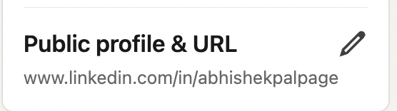

Example: https://www.linkedin.com/in/abhishekpalpage/